Carbody Structure and Exterior

Introduction

Use

Purpose

Parts List

All figures are assigned to an individual page unless views are required to show a complete listing of equipment.

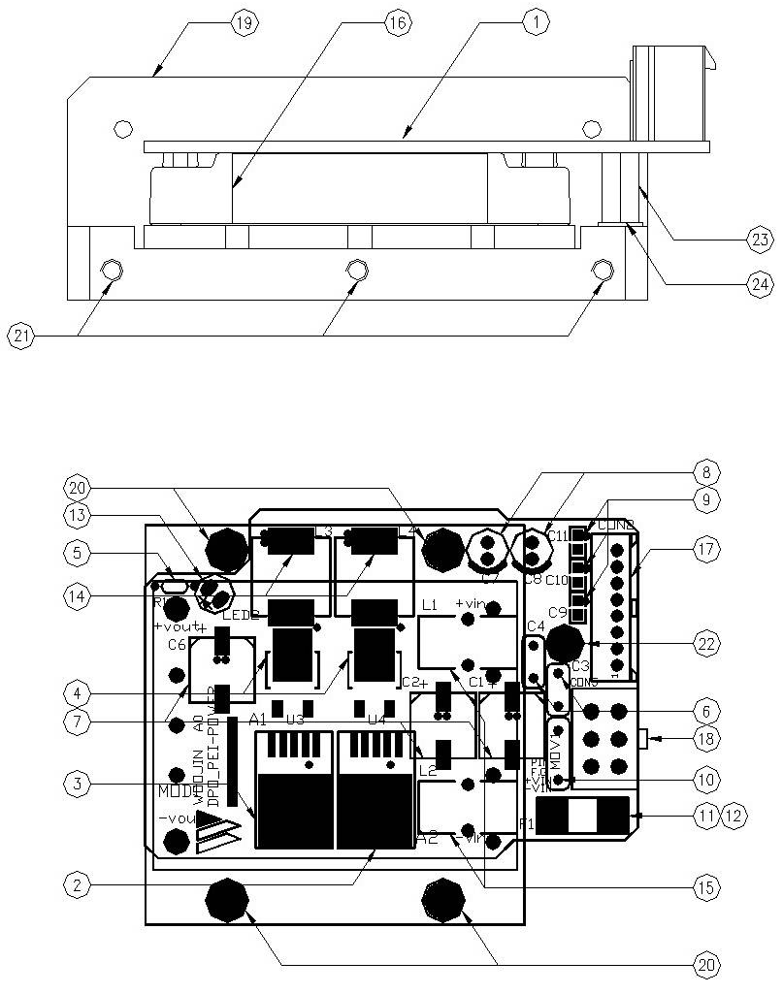

Figure 2.1. PEI Power Board
Table 1 - Figure 2.1. PEI Power board
FIG No. | PART NUMBERS |  |  | ITEM DESCRIPTION | VENDOR CODE | QTY
 | HRC | VENDOR | DTP
1 |  | DPO_PEI-POWER A0 |  | . BOARD | HANSAEM | 1
2 |  | LM2576-12 |  | . IC | ON SEMI  HTC | 1
3 |  | LM2576-5 |  | . IC | ON SEMI  HTC | 1
4 |  | DE10SC3L |  | . DIODE | SINDENGEN | 2
5 |  | MR1/8W4.7KΩFTB  MFR0318FAEW4701MA  SN1/8KT52R4.7KΩF |  | . CARBON FILM RESISTOR | ABCO  RARA  JEIL | 1
6 |  | EKR3A222K09FK |  | . CAP-CE | SAMWHA | 2
7 |  | KMG50VB220M5.0TP  RD1H227M1012MPE |  | . ELECTROLYTIC CAPACITOR | SAMYOUNG  SAMWHA | 3
8 |  | KMG50VB47M2.0TP  RD1H476M6L011CS |  | . ELECTROLYTIC CAPACITOR | SAMYOUNG  SAMWHA | 2
9 |  | CL21B104KBCNNNC |  | . MLCC | SAMSUNG | 3
10 |  | INR10D151  SVC151D-10A |  | . VARISTOR | AMOTECH  SAMWHA | 1
11 |  | 0451010.MRL |  | . FUSE-SMD | LITTLE FUSE | 1
12 |  | 0154010.DRTL |  | . FUSE HOLDER | LITTLE FUSE | 1
13 |  | 3G4HD00025, Y-GREEN  SM3317, Y-GREEN |  | . LED | DAGUANG  AUK | 1
14 |  | SHP1260P-F101A |  | . CHOKE-SMD | TOKYO COIL | 2
15 |  | FL101 |  | . CHOKE | HANAM | 2
16 |  | VI-J23-CZ |  | . DC/DC CONVERTER | VICOR | 1
17 |  | SMW250-08 |  | . CONNECTOR | YEONHO | 1
18 |  | LWD1140-06 |  | . CONNECTOR | HANLIM | 1
19 |  | AI, D78 X L73 X H40 |  | . HEAT SINK | EGPOWER | 1
20 |  | ROUND, M3XL10mm |  | . BOLT |  | 4
21 |  | FLAT, M3XL10mm |  | . BOLT |  | 3
22 |  | ROUND, M3XL6mm |  | . BOLT |  | 1
23 |  | SUPPORT-BOLT(HEXA) M3X10 |  | . SUPPORT | EGPOWER | 1
24 |  | FLAT, M3, D4.8mm |  | . WASHER |  | 1

